|  |
| --- |
| **New standards: Task Server Installation – Standards 1.1** |

1 Intro 2

2 Prerequisites 2

3 Workflow installation 3

4 Verify the installation 4

# Intro

This manual is focused on the deployment of a task server on the new standards of JDN with an automated workflow installation.

This manual should only be used on servers that have been deployed from a task server template.

# Prerequisites

An active task server that is deployed from template on the correct fixed IP address: X.X.X.15

GPOs applied on the servers

An active VPN connection

**If the site will not have a VPN connection when it is installed on site a configuration change will need to be performed by the ICT System Engineers after it has been deployed.**

Member of the JDN_GAP_ALTIRIS_SITE_SERVER_DEPLOYMENT_CONSOLE AD group for access to the workflow

Assure that you have initialized Disk1 in Disk Management of the XX-tasks01 and XX-apps01 server, choose drive letter **E:** for both Tasks and Apps server and Drive name **Data.**

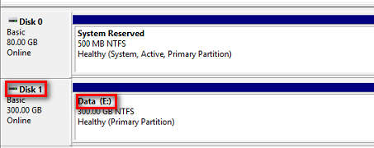

# Workflow installation

Go to <http://vm-alt-wf01.jandenul.com/SiteServerDeployment/> you will be presented with the following form:

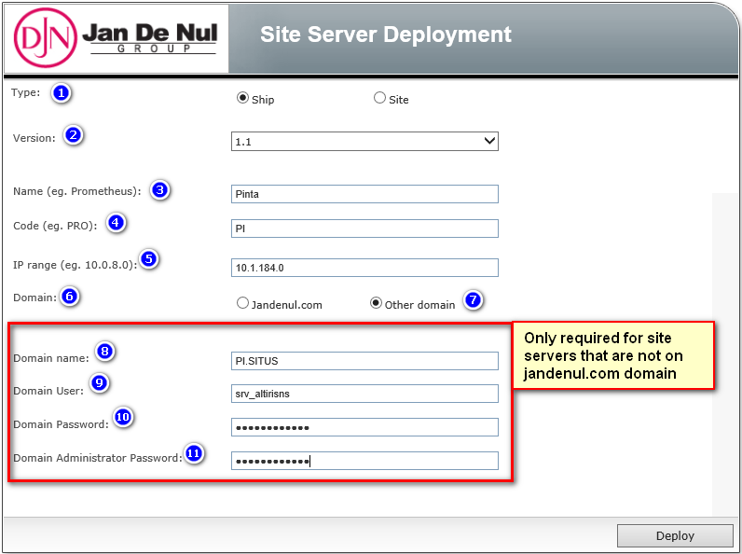

1. Select the appropriate type
2. Adjust the Version according to your Standards version.
3. Enter the full name of the site/ship
4. Enter the short name of the site/ship
5. Enter the **IP range** of the site/ship  
   **Note: This is not the IP address of the task server!!!**
6. If you select jandenul.com here the you can click deploy to move on to the next steps
7. If you select other domain another part of the form will become visible
8. Enter the name of the domain (for example PI.SITUS)
9. This field will be filled in automatically in the following format [srv_altirisns@IN.SITUS](mailto:srv_altirisns@IN.SITUS)
10. Enter the password of the srv_altirisns user
11. Enter the password of the domain administrator account and click Deploy

Before executing the next step, always verify that the previous step was successful.

Deploy >> Next >> Next >> Next >>

After entering this data you will configure each part of the process by a wizard like deployment (next, next). **Should any of these steps fail for some reason is it very important to not execute the same steps twice as this could cause data corruption in the Altiris environment!**

# Verify the installation

After completing the workflow there should be an agent installed on the management, apps and tasks VM. You can verify this by going to the VM and clicking the Symantec Management Agent icon as shown below.



After 2-4 hours all the functionality should be available in the task server agent and it should have a package server tab in the agent. From this moment on it will start syncing the packages to the server. You can check this progress by watching the ready packages in the package server tab.

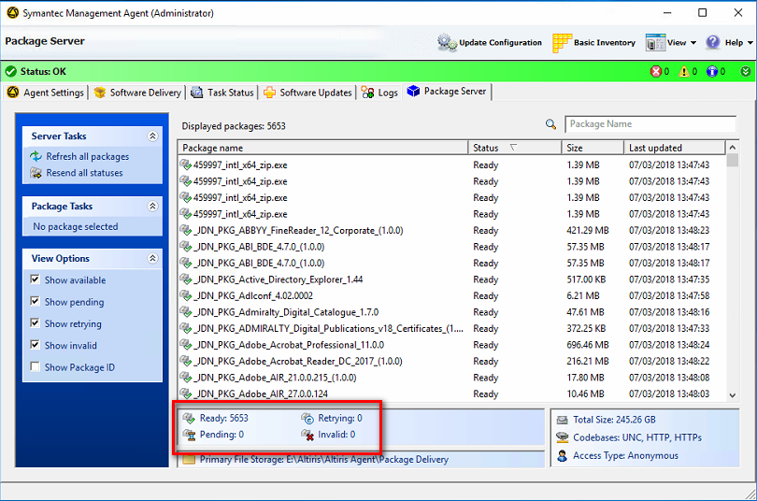

By default the package server will only use 10% of the available bandwidth. If you want to speed up the syncing of the packages you can **temporary** uncheck the following checkbox.

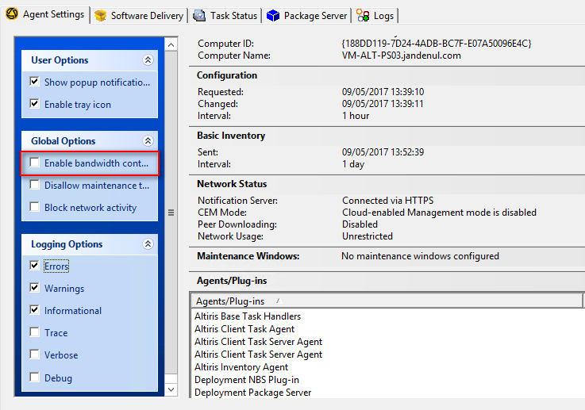

**It is important that this option is enabled again after all packages have been synced.**